(Approx. 759 words)

Tom’s Tech-Notes
Windows 10 – Tuning Up Your Start Menu
Tom Burt, Vice President, Sun City Summerlin Computer Club, Nevada
http://www.scs-cc.com
tomburt89134 (at) cox.net

Windows 10, originally released in July, 2015, recently saw its second major update (V1607-Anniversary) in July, 2016. By now, most Windows 10 users have received that update. Originally, I had mixed feelings about the new hybrid “list and tiles” Start menu. However, I’ve gradually come to like it as a way to declutter my desktop and actually make it easier to find things. Here’s a screen of my desktop today:
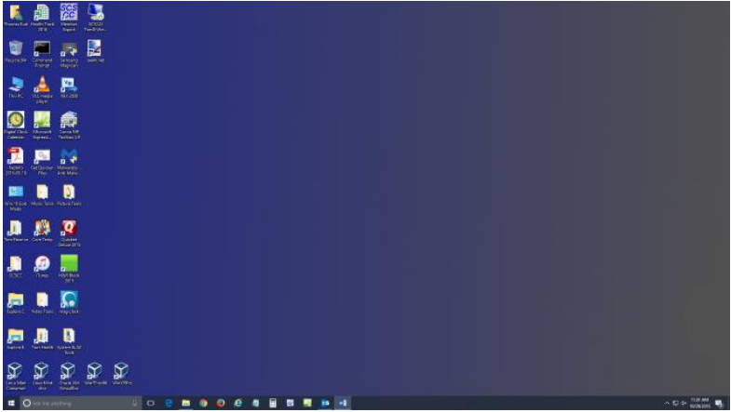

The exact details don’t matter. As you can see, I still have a lot of icons on the desktop that I use to launch applications. Over a year of using Windows 10, I’ve steadily reduced the original number of icons by half to what you see in the screen shot. However, even now, when I’m working intensely and need to start an application while I have others running, it gets irritating. I have to minimize those other apps to uncover the desktop icons so I can double-click the one I need to launch the new app. Also, to launch
from a desktop icon, I need to double-click it – something my stiff fingers no longer do well.

The Windows 10 V1607 Start Menu is the best incarnation yet and helps me with some of the above issues. You can open the start menu by clicking the flag icon at the bottom left of the screen or by pressing the Windows key. Following is a screen shot of my current Start menu:
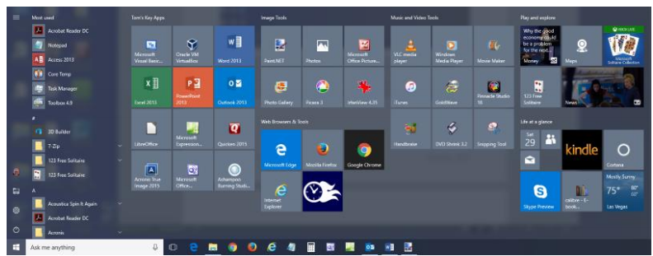

I have stretched the Start menu out to allow four 3-column groups and have almost all my tiles sized to the medium, square size. In this layout, I don’t need to scroll to find a particular tile. The tiles are grouped and labeled along functional lines, such as “Tom’s Key Apps”, Image Tools, “Movie and Video Tools”, “Web Browsers and Tools” and others. The app tiles I use most are at the top left.

To launch an app, I just press the Windows key to pop open the Start menu and then click the tile of the app. The app starts up and the Start menu closes back up. I no longer need to uncover desktop icons and double click. Tiles are especially nice on hand-held touch screen devices.

Down the left side of the Start menu is the standard complete list of all installed programs. You can right-click on any program in the list and choose “Pin to Start” to add a tile for that program to the array of tiles. You can then drag the tile to wherever you want it in either an existing group or a new group.

You can right click the tile to adjust its size to small, medium, wide or large. The wide and large sizes are useful for “modern” apps that animate their tiles with “live” content. News and Weather apps are examples. The medium tiles display the app’s name and an icon.

You can adjust the width of the Start menu by opening it, positioning the mouse cursor over the right edge until the cursor turns to a double arrow, and then dragging to the right (to widen) or to the left (to narrow). Tile groups will automatically move to fit the new shape of the Start menu window. You can adjust the height of the Start menu by opening it, positioning the mouse cursor over the top edge until the cursor turns to a double arrow, and then dragging up or down.

You can rename tile groups by clicking the space just above the group and then typing a name. You can move entire groups around by clicking and dragging the group’s title space.

To remove a tile from the Start menu, right click it and select “Unpin from Start”. That program will still be listed in the Start menu’s left-side list of all installed programs. I got rid of quite a few of the default tiles for apps I never use.

To add a tile/icon to the Windows Taskbar, right click either the tile or the program name in the program list. In the pop-up menu, hover the mouse over the “More” option to get a second pop-up and choose “Pin to Taskbar”. After the icon appears on the Taskbar, you can drag it left or right to where you want it to be permanently.

So, that’s a quick summary of things you can do to make the Windows 10 Start menu work better for you!

